SIMATS ENGINEERING

ASSESSMENT TOOL 3: Inference Quiz

COURSE NAME: | ARTIFICIAL INTELLIGENCE  AND EXPERT SYSTEMS | COURSE CODE: | MLA01

COURSE OUTCOME COVERED

CO3: Analyze and select appropriate agent strategies for different types of environments and problem settings (BTL 4)

Assessment Tool Weightage: 20%

Each question carries equal marks.
Total Marks: 50 Time : 45 Mins

Code of Conduct:

I Mokshitha Kilari (192525413) (Name / Reg No) certify that this submission is my original work and that I have adhered to the guidelines specified for this assessment. I understand that any violation of academic integrity rules will result in disciplinary action.

Signature of the student: MOKSHITHAKILARI

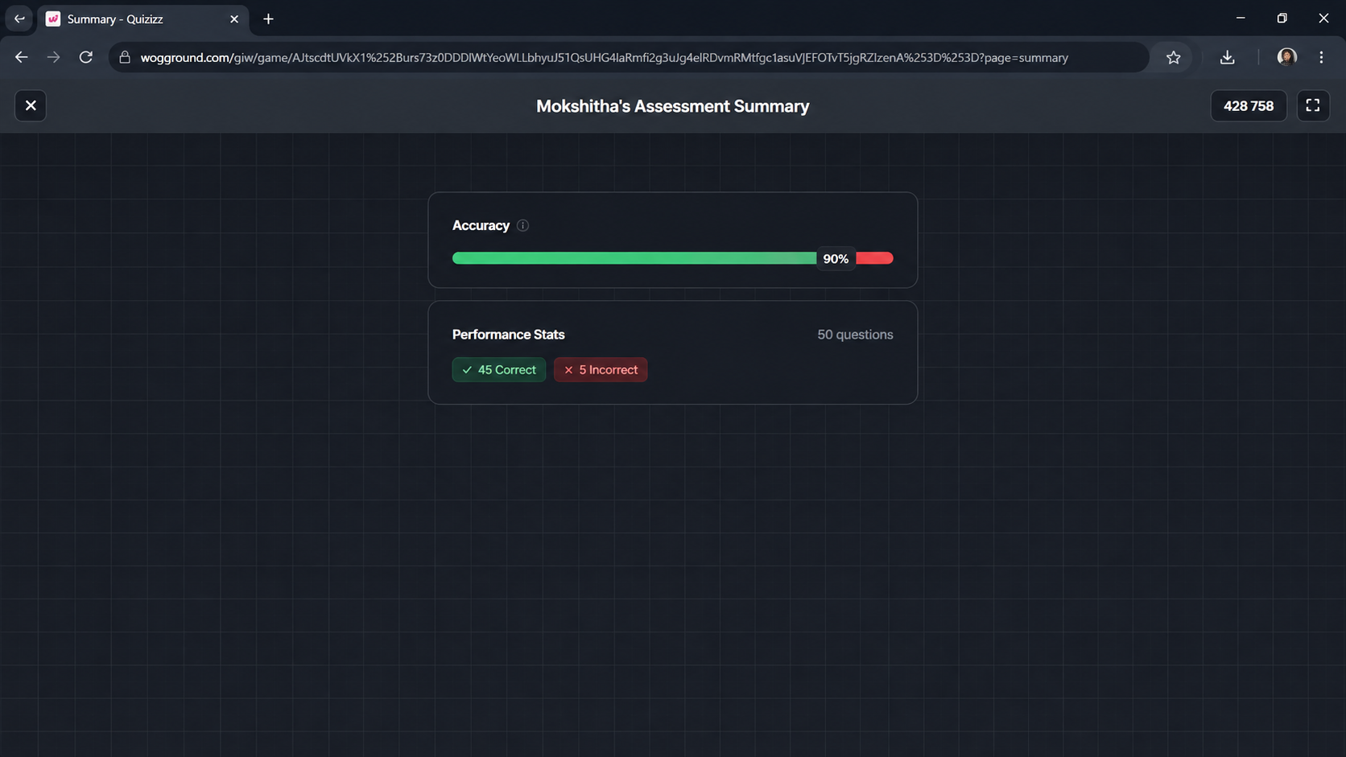

RUBRICS FOR CALCULATION:

Each correct answer is of 1 mark.

